Create a new maven module

Provide necessary params as below

Navigate to spring initializer and get the dependencies

Open the explorer and copy the dependencies

Paste them in the notifications-service pom.xml and reload the maven

Ensure all the dependent components are started. Always Start the Zookeepr first then kafka.

Once all the modules are started and appropriate changes are done in order service and notifications service, we can invoke the curls as below.

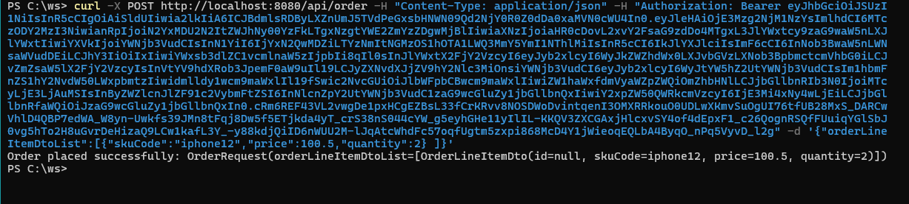

Logs in Order Service

Logs in Notifications Service

